**CRM APPLICATION FOR JEWEL MANAGEMENT**

College Name : Sasurie college of Arts and Science

College code : 5Y

TEAM ID :

**TEAM MEMBERS :**

Team Leader Name : Jesintha.J

Email : jesinthajames01@gmail.com

Team Member 1 : Aswin .N

Email : aswinnaswin1@gmail.com

Team Member 2 : Felix john.J

Email : felixjohn18007@gmail.com

Team Member 3 : Hasika.R

Email : hasileela01@gmail.com

Team Member 4 : Sivasakthi.M

Email :

**INTRODUCTION :**

A Customer Relationship Management (CRM) application for jewel management is a specialized software solution designed to help jewelry businesses streamline their customer interactions, sales processes, and inventory management. Unlike a general CRM, this application is tailored to the unique needs of the jewelry industry, where customer trust, personalized service, and product variety play a vital role.

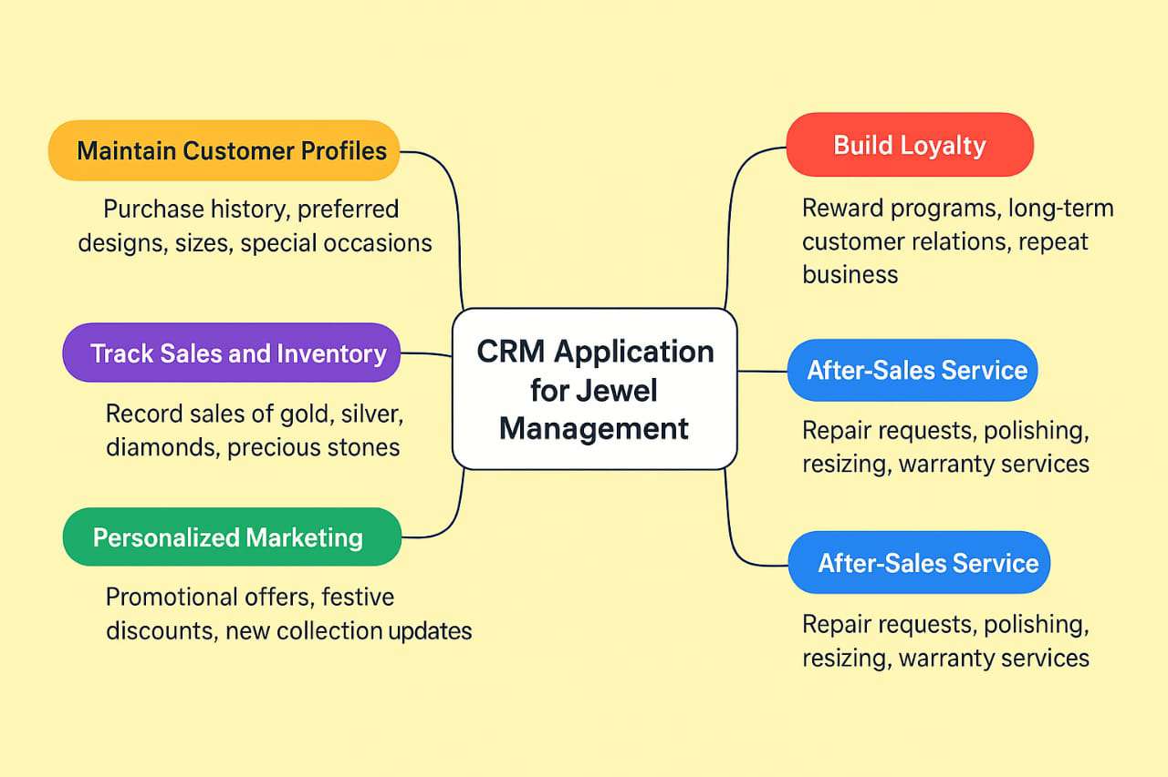

**DEVELOPMENT PHASE**

**Creating Developer Account:**

By using this URL : <https://developer.salesforce.com/signup>

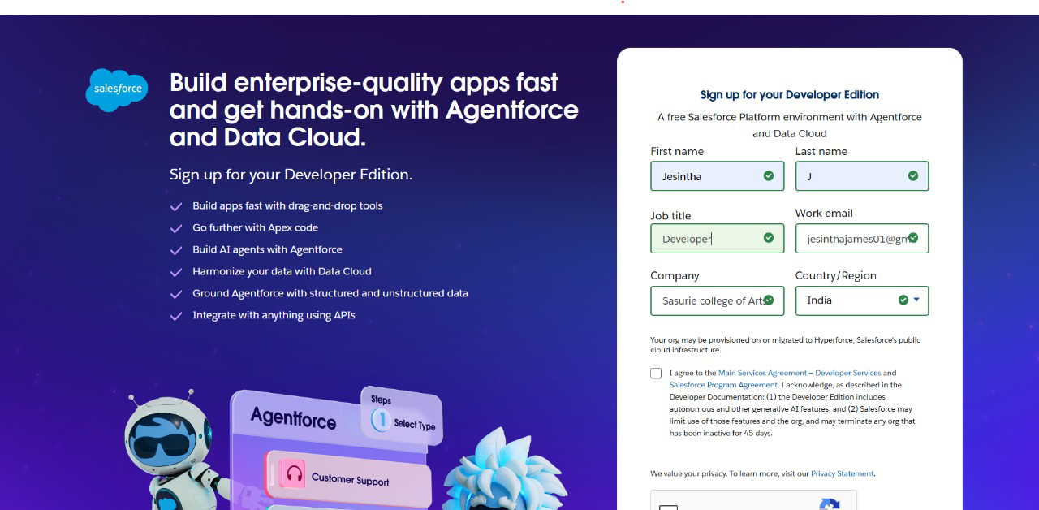

* Create Custom Object

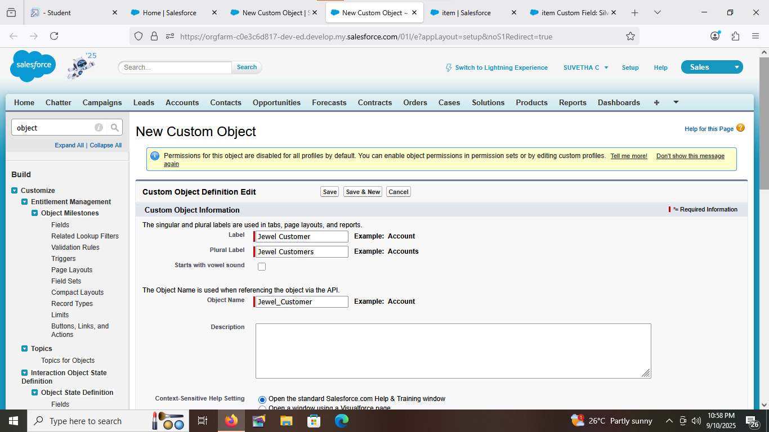

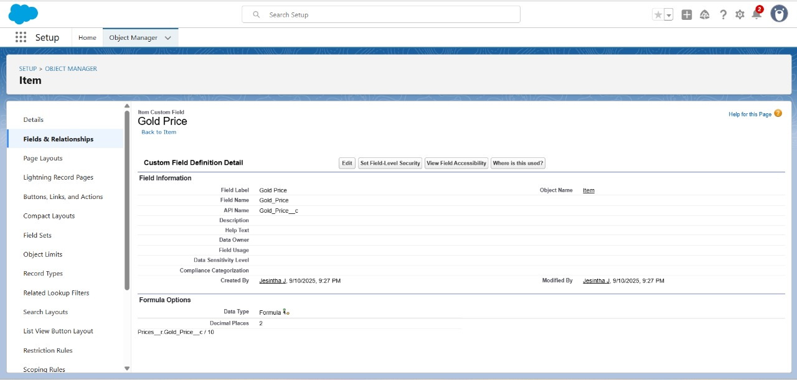

* Creating Custom Objects in Tabs

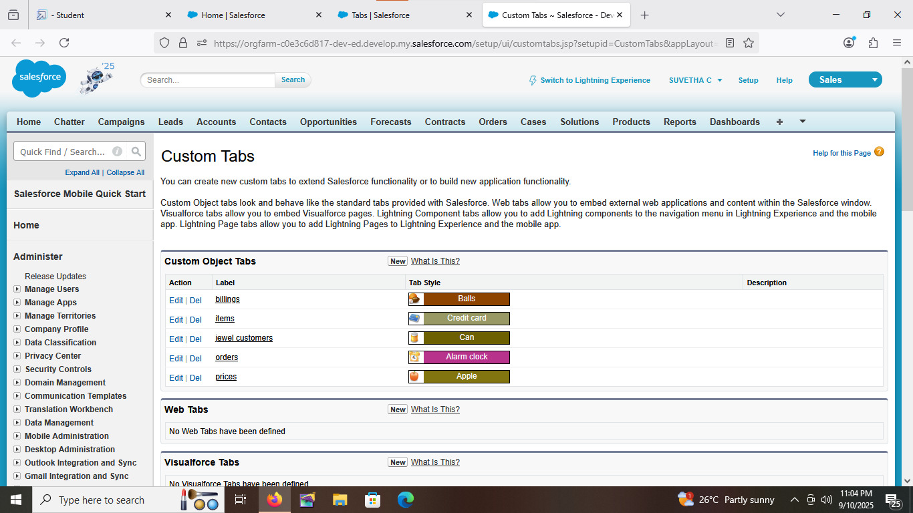

* Lightning App

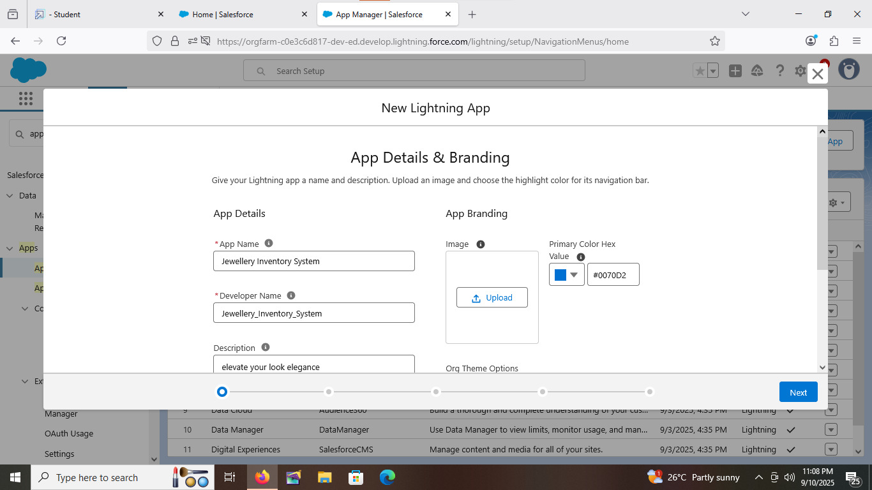

* Creating fields

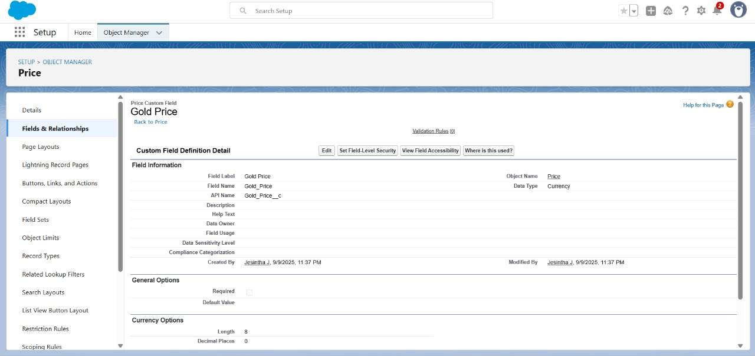

* Remaining Fields using custom objects

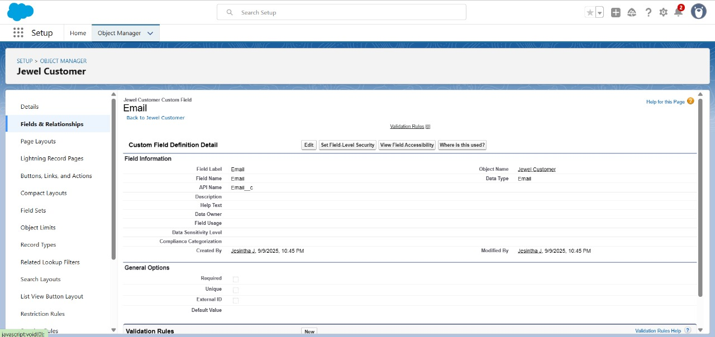

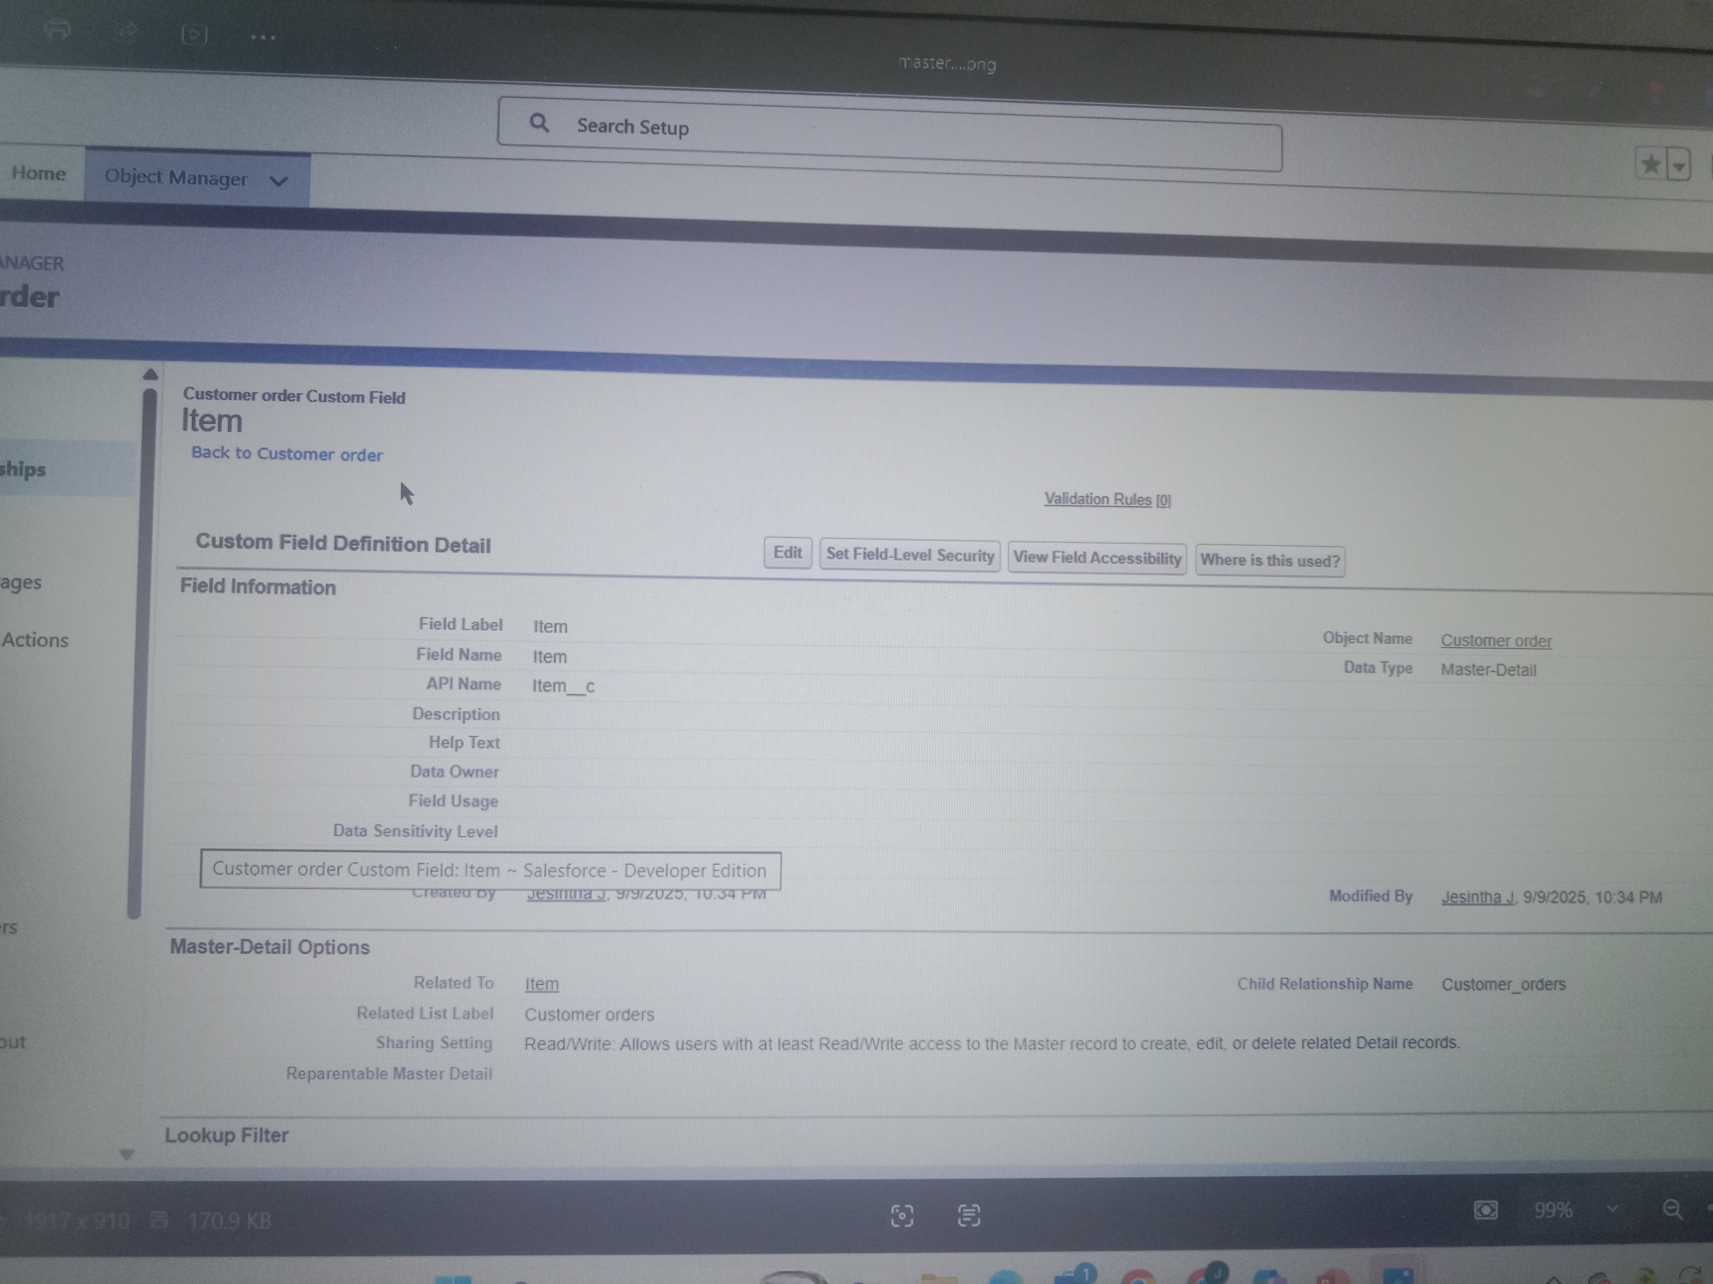

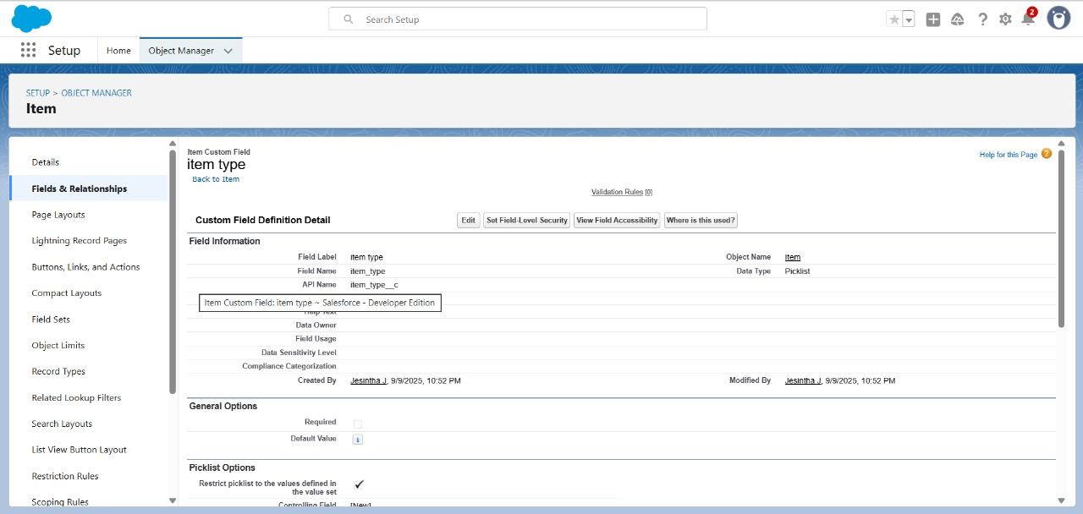

* Creating Field Dependency

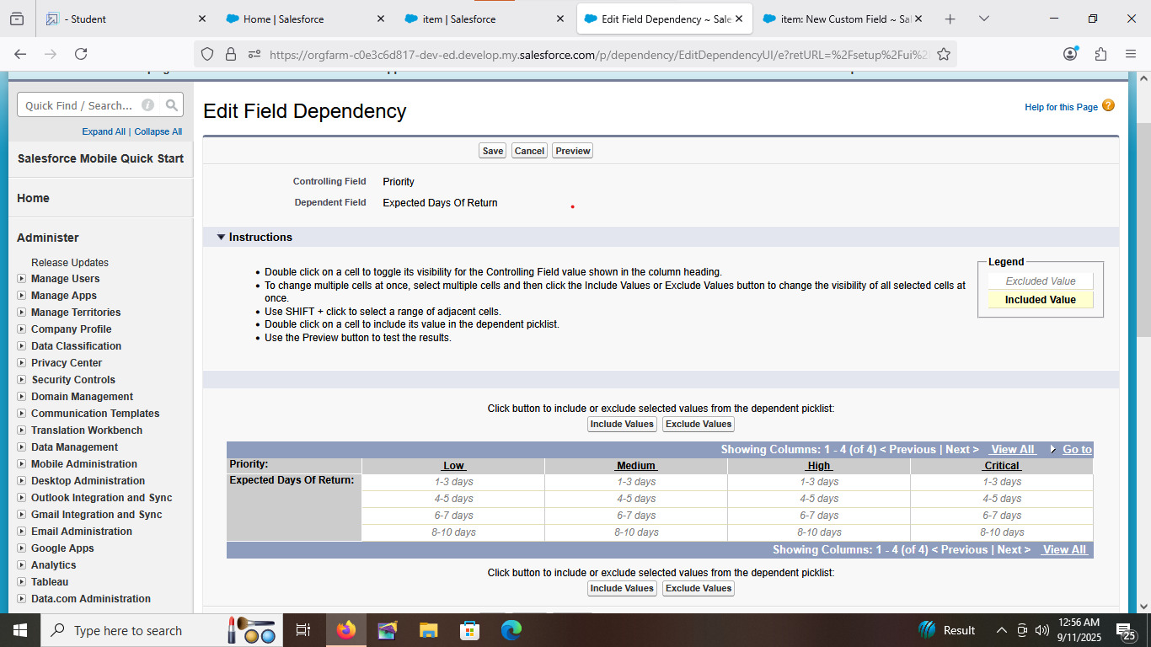

* Creating Validation Rule

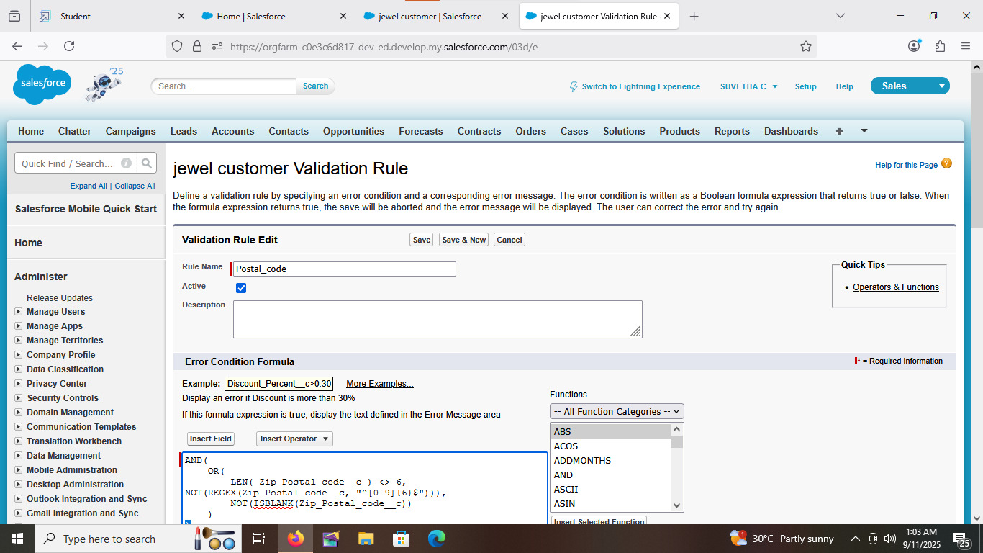

* Creating Profiles

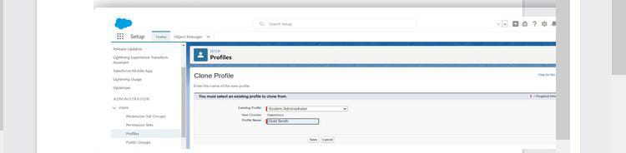

* Creating Workers Gold smith

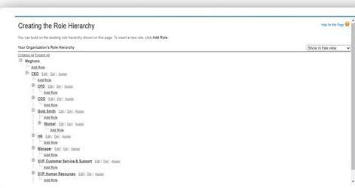

* Creating New Users

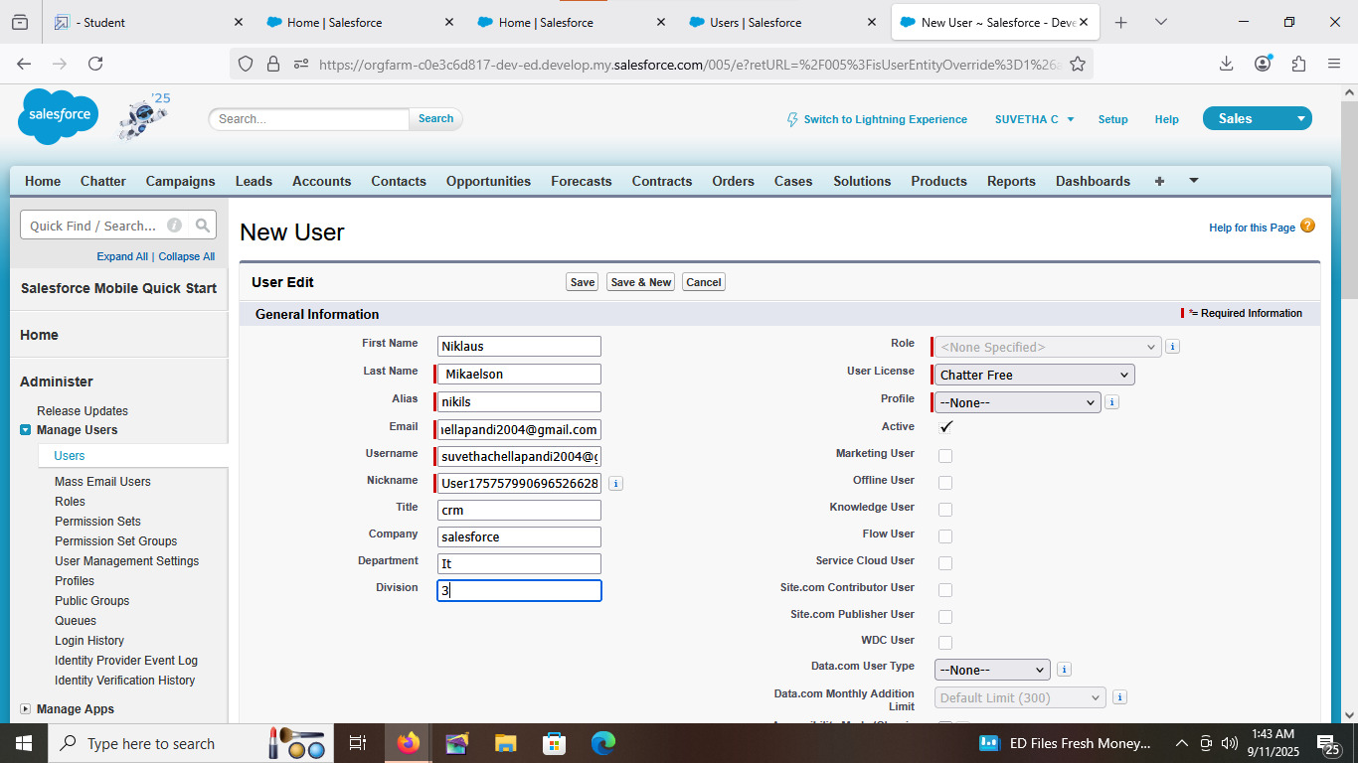

**CONCLUSION**

The CRM application for jewel management plays a vital role in modernizing the jewelry business by integrating customer relationship management with sales, inventory, and marketing functions. It not only helps in maintaining accurate records of customers and their preferences but also supports personalized services that enhance trust and loyalty. By streamlining operations such as lead tracking, stock monitoring, promotional campaigns, and after-sales support, the application enables jewel businesses to deliver superior customer experiences.